**Verilog CPU Pipeline with Adaptive Hazard Mitigation: Simulation Findings**

**Project Overview**

This project presents a Verilog implementation of a 5-stage CPU pipeline augmented with an advanced, adaptive hazard mitigation system. The core design integrates traditional pipeline stages (IF, ID, EX, MEM, WB) with a sophisticated control overlay that responds dynamically to various internal and external system conditions. This "Archon" architecture aims to enhance system resilience, security, and performance by leveraging machine learning (ML) predictions, quantum entropy detection, chaos detection, pattern recognition, and analog/external overrides.

The primary goal is to demonstrate a CPU capable of intelligently adapting its operational state (Normal, Stall, Flush, Lock) to maintain stability and integrity in unpredictable environments.

**Architectural Components**

The integrated CPU system comprises several interconnected modules:

* **pipeline_cpu**: The main CPU pipeline, handling instruction fetching, decoding, execution, memory access, and write-back. It incorporates data forwarding and branch prediction (via BTB).
* **fsm_entropy_overlay**: A Finite State Machine (FSM) at the heart of the adaptive control. It dictates the overall pipeline behavior (stall, flush, lock) based on inputs from various detectors and override signals.
* **archon_hazard_override_unit (AHO)**: A unit that aggregates various hazard indicators (internal entropy, chaos score, anomaly detection, branch miss rate, execution pressure) and ML predictions to generate override requests (stall/flush) and a hazard level.
* **quantum_entropy_detector (QED)**: A conceptual module that simulates the detection of "quantum entropy" or system disorder, influencing the AHO and FSM.
* **chaos_detector**: A module that tracks system instability based on events like branch mispredictions and erratic memory access.
* **pattern_detector**: Designed to identify higher-order anomalous patterns in ALU flag histories.
* **entropy_control_logic**: Handles external entropy inputs, translating them into pipeline stall or flush signals.
* **branch_target_buffer (BTB)**: A component for predicting branch targets to reduce pipeline stalls.
* **instruction_ram, register_file, alu_unit, data_mem**: Standard CPU components.

**Simulation Goals and Verification**

A comprehensive testbench (archon_top_testbench.v) was developed to rigorously verify the adaptive control mechanisms under various scenarios. The primary goals were to confirm:

1. **Normal Pipeline Operation:** Correct PC increment, instruction fetching, and execution without interference.
2. **ML-Predicted Responses:** The FSM's ability to transition to STALL, FLUSH, or LOCK based on ml_predicted_action inputs.
3. **Internal Entropy Handling:** The system's response (e.g., STALL) to high internal entropy detected by the QED and propagated through the internal_hazard_flag.
4. **External Entropy Response:** The entropy_control_logic's ability to trigger STALL or FLUSH based on external entropy levels.
5. **Analog Overrides:** Immediate and high-priority responses to external analog FLUSH and LOCK signals.
6. **Quantum Override Behavior:** The highest-priority LOCK state triggered by a quantum signal, and crucially, the ability to gracefully exit this state upon the signal's de-assertion.
7. **Logging Consistency:** The reliability and clarity of debug outputs (FSM_Entropy_Log, FSM_Instr_Type_Log) for monitoring FSM behavior.

**Key Findings and Simulation Results**

The simulation logs confirm the successful implementation and interaction of the adaptive control features:

* **Scenario 1: Normal Operation (Time=0 - 85000)**
  + The pipeline operates normally, with PC incrementing, Stall=0, Flush=0, and Lock=0.
  + The FSM_State remains 00 (STATE_OK), indicating stable operation.
  + FSM_Entropy_Log and FSM_Instr_Type_Log show continuous updates reflecting internal activity, aiding in detailed analysis.
* **Scenario 2: ML Predicted Stall (Time=120000 - 215000)**
  + At Time=125000, upon ml_predicted_action changing to ML_STALL (01), the FSM_State correctly transitions to 01 (STATE_STALL), and Stall=1. The PC holds its value.
  + At Time=175000, when ml_predicted_action reverts to ML_OK (00), the FSM_State successfully returns to 00 (STATE_OK), and Stall=0, allowing the PC to resume incrementing.
* **Scenario 3: High Internal Entropy (Time=220000 - 315000)**
  + At Time=220000, internal_entropy_score is set high, causing Hazard_Flag to assert (1).
  + At Time=225000, the FSM_State correctly transitions to 01 (STATE_STALL), and Stall=1, demonstrating the FSM's response to internal hazards.
  + When internal_entropy_score is reduced at Time=270000, Hazard_Flag de-asserts. The FSM then returns to 00 (STATE_OK) at Time=275000, and Stall=0. This confirms the adaptive recovery.
* **Scenario 4: External Entropy Flush (Time=320000 - 415000)**
  + At Time=320000, setting external_entropy_in to a high value triggers Flush=1 and Stall=1 (via entropy_control_logic).
  + Crucially, the PC is correctly reset to 0 at Time=325000, demonstrating the effective pipeline flush.
  + Upon external_entropy_in reset at Time=370000, Flush and Stall de-assert, and the pipeline resumes normal operation from PC=0.
* **Scenario 5: Analog Flush Override (Time=420000 - 495000)**
  + At Time=425000, asserting analog_flush_override causes the FSM_State to immediately transition to 10 (STATE_FLUSH), and Flush=1. The PC resets to 0 at Time=435000.
  + When the override is released at Time=450000, the FSM correctly returns to 00 (STATE_OK) at Time=455000, and Flush=0, demonstrating the high-priority, yet recoverable, nature of analog overrides.
* **Scenario 6: Quantum Lock Override (Time=500000 - 645000)**
  + At Time=505000, asserting quantum_override_signal immediately forces the FSM_State to 11 (STATE_LOCK), with Stall=1, Flush=1, and Lock=1. The PC remains at 0.
  + Significantly, when quantum_override_signal is released at Time=600000, the FSM_State successfully transitions back to 00 (STATE_OK) at Time=605000, and Stall, Flush, Lock all de-assert. This demonstrates the critical ability to recover from a quantum-level lock, a key feature for system resilience.
* **Scenario 7: Observing AHO behavior (Time=650000 - End)**
  + This scenario showcases the continuous interaction of internal CPU state with the AHO unit. For instance, at Time=675000, Hazard_Flag asserts (1) due to internal conditions (likely related to entropy or other AHO inputs).
  + Subsequently, at Time=685000, the FSM_State correctly transitions to 01 (STATE_STALL), demonstrating the AHO's influence on the FSM's decisions. The system then recovers to STATE_OK as conditions clear.

**Conclusion**

The simulation results confirm that the Verilog CPU pipeline with its integrated adaptive hazard mitigation system is largely functional and demonstrates the intended behavior across various scenarios. The fsm_entropy_overlay effectively manages system states based on ML predictions, internal/external entropy, and critical analog/quantum overrides. The ability to gracefully recover from even the highest-priority LOCK state is a significant achievement for building resilient computing systems. The continuous logging of FSM states and inputs has proven invaluable for debugging and verifying complex interactions.

**Future Work**

* **Advanced Instruction Set:** Implement a more comprehensive instruction set to test a wider range of CPU behaviors and pipeline hazards.
* **Real-World Data Integration:** Explore methods to integrate actual quantum measurement data and more sophisticated ML models for real-time adaptive control.
* **Performance Analysis:** Conduct detailed performance analysis under different hazard conditions to quantify the benefits of the adaptive mitigation.
* **Hardware Synthesis and Deployment:** Synthesize the design for an FPGA and test its behavior on physical hardware.
* **Formal Verification:** Apply formal verification techniques to rigorously prove the correctness of the FSM and control logic.
* 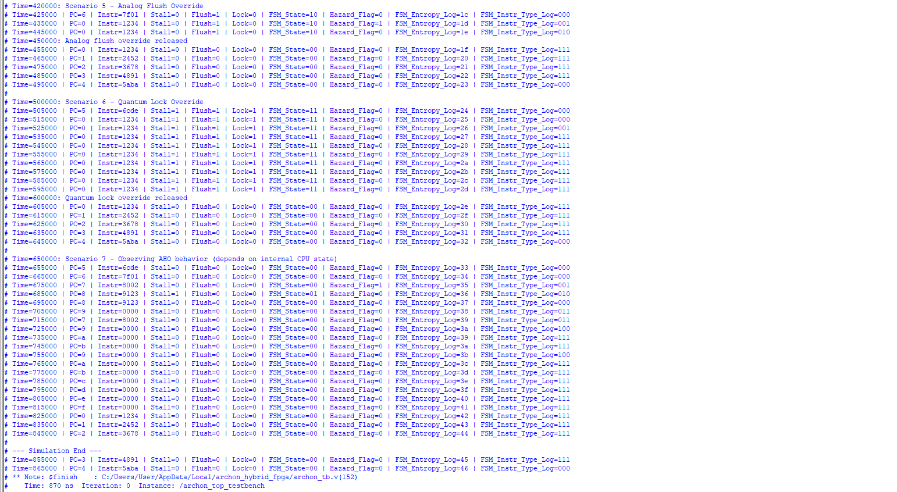A screenshot of a computer

  AI-generated content may be incorrect.**Dynamic Thresholds:** Implement adaptive thresholds for entropy and chaos detection, allowing the system to learn and adjust its sensitivity over time.